## **Artificial**

## **Intelligence and Machine Learning**

Project Report

Semester-IV (Batch-2022)

**FAKE NEWS DETECTOR**



**Supervised By: Submitted By:**

Ms.Shagun Sharma

Mr.Tushar Khitolia Aashvi Chawla-2210990019

Kshitij Raj Shukla -2210990526

Liv Arpit-2210990543

Lokesh Vaid-2210990545

**Department of Computer Science and Engineering**

**Chitkara University Institute of Engineering & Technology, Chitkara University, Punjab**

**INTRODUCTION**

* 1. **Problem Statement**

In today's digital age, the proliferation of fake news has become a significant concern, often leading to misinformation, confusion, and even societal unrest. To address this challenge, there is a need to develop a robust fake news detector using Python.

The goal of this project is to create a machine learning-based system capable of accurately distinguishing between real and fake news articles. The system will analyze various textual features of news articles and employ natural language processing (NLP) techniques to classify them as either authentic or deceptive.

* 1. **MOTIVATION**

Building a fake news detector with Python is motivated by the urgent need to address the pervasive issue of misinformation in today's digital age. Misinformation, often disseminated through social media and online platforms, can have profound consequences on public opinion, political discourse, and societal well-being. By creating a fake news detector, developers aim to empower individuals to critically evaluate the credibility of news sources and content, thereby fostering media literacy and informed decision-making.

The development of a fake news detector also represents an opportunity to leverage cutting-edge technologies such as natural language processing (NLP), machine learning, and data science. These tools enable the analysis of textual data to identify patterns, linguistic cues, and other indicators of misinformation. By applying advanced algorithms and techniques, developers can build robust models capable of detecting fake news with high accuracy.

Moreover, the creation of a fake news detector contributes to ongoing research efforts aimed at understanding and combating misinformation. By experimenting with different approaches, algorithms, and methodologies, developers can contribute valuable insights to the broader scientific community and inform future developments in the field.

Ultimately, the goal of building a fake news detector with Python is to empower users to make more informed choices about the information they consume and share online. By providing individuals with tools to discern between trustworthy and untrustworthy sources, developers play a crucial role in preserving the integrity of public discourse and upholding the principles of truth and accuracy in journalism.

* 1. **OBJECTIVES**

**1.Dataset Acquisition: Collect a diverse dataset of news articles labeled as either real or fake to train and evaluate the model.**

**2.Data Preprocessing: Clean and preprocess the text data by removing noise, such as HTML tags, punctuation, and stopwords, and perform tokenization and lemmatization.**

**3.Model Development: Develop and train machine learning models, such as logistic regression, random forest, or neural networks, to classify news articles based on their features.**

**4.Model Evaluation: Evaluate the performance of the trained models using appropriate metrics, such as accuracy, precision, recall, and F1-score, through cross-validation and/or holdout validation.**

**5.Deployment: Implement the trained model into a user-friendly application or web service that allows users to input news articles and receive predictions on their authenticity.**

**6.Continuous Improvement: Continuously monitor and update the fake news detector to adapt to evolving news sources and deceptive tactics.**

* 1. **SIGNIFICANCES**

**The significance of building a fake news detector with Python lies in its potential to address several critical issues:**

**1. Combatting Misinformation: Fake news has become a pervasive problem in the digital age, influencing public opinion, shaping political discourse, and even posing threats to public safety. By developing a fake news detector, we can help mitigate the spread of misinformation and protect individuals from being misled by false or misleading information.**

**2. Promoting Media Literacy: Building a fake news detector encourages users to become more discerning consumers of information. It promotes critical thinking and media literacy by empowering individuals to evaluate news sources, assess the credibility of information, and recognize common tactics used in spreading fake news.**

**3. Protecting Democratic Values: In democratic societies, access to accurate information is essential for informed decision-making and civic engagement. Fake news undermines these values by distorting reality and manipulating public opinion. By detecting and flagging fake news, we uphold the integrity of democratic processes and safeguard the public's right to truthful information.**

**4. Enhancing Trust in Journalism: Trust in traditional media outlets and journalism has declined in recent years, partly due to the proliferation of fake news. Building a fake news detector demonstrates a commitment to journalistic integrity and accountability, helping to rebuild trust in reputable news sources and ensuring that credible reporting continues to be valued and respected.**

**5. Advancing Technology: Developing a fake news detector involves the application of cutting-edge technologies such as natural language processing (NLP), machine learning, and data analysis. By leveraging these tools, we not only create effective solutions for detecting fake news but also push the boundaries of technological innovation and contribute to advancements in the field of artificial intelligence.**

**6. Empowering Users: Ultimately, the significance of building a fake news detector lies in its ability to empower individuals to navigate the complex landscape of online information more effectively. By providing users with the tools and knowledge to identify fake news, we enable them to make informed decisions, participate more responsibly in online discourse, and contribute to a healthier and more informed digital ecosystem.**

* 1. **FEATURES**

**1. Textual Features:**

**- Word frequency: Counting the frequency of words in the article.**

**- Sentiment analysis: Assessing the overall sentiment of the text, such as positive, negative, or neutral.**

**- Named entities: Identifying named entities (e.g., persons, organizations, locations) mentioned in the article.**

**- Linguistic features: Analyzing linguistic characteristics such as vocabulary richness, readability scores, and syntactic structures.**

**2. Source-based Features:**

**- Domain credibility: Assessing the credibility of the news source based on its domain name or reputation.**

**- Source diversity: Analysing whether the news source is known for producing diverse and balanced content.**

**- Source bias: Evaluating the political or ideological bias associated with the news source.**

**- Author reputation: Assessing the credibility and expertise of the article's author based on past publications or qualifications.**

**3. Metadata Features:**

**- Publication date: Analysing whether the article's publication date aligns with the timeline of the reported events.**

**- Article length: Assessing whether fake news articles tend to be shorter or longer than real news articles.**

**- Social media engagement: Analysing metrics such as likes, shares, and comments on social media platforms to gauge the article's popularity and potential virality.**

**4. Contextual Features:**

**- Cross-referencing: Checking the consistency and coherence of the article's content with other reputable sources or fact-checking databases.**

**- Event detection: Analysing whether the article is reporting on a recent or ongoing event and assessing its relevance and accuracy in the context of current events.**

**5. Statistical Features:**

**- Statistical measures: Calculating statistical measures such as mean, median, standard deviation, and skewness of word frequencies or sentiment scores.**

**- Information entropy: Assessing the uncertainty or randomness of word distributions within the article.**

**- Correlation analysis: Analysing correlations between different features to identify patterns or redundancies in the data.**

**These features can be combined and processed using various techniques such as feature engineering, dimensionality reduction, and normalization before being fed into a machine learning model for classification. By leveraging a combination of these features, a fake news detector can effectively distinguish between fake and real news articles with high accuracy.**

1. **PROBLEM DEFINITION AND REQUIREMENTS**

In today's digital age, the proliferation of fake news has become a significant concern, often leading to misinformation, confusion, and even societal unrest. To address this challenge, there is a need to develop a robust fake news detector using Python.

The goal of this project is to create a machine learning-based system capable of accurately distinguishing between real and fake news articles.

* 1. **SOFTWARE REQUIREMENTS**
     1. **Programming Language:** Python
     2. **Data Analysis and Visualization:** Pandas, NumPy, Matplotlib, Seaborn
     3. **Machine Learning Libraries:** Scikit-learn
     4. **Development Environment:** Visual Studio Code
  2. **HARDWARE REQUIREMENTS**
     1. **Processor:** Multi-core processor
     2. **RAM:** 8GB or more
     3. **Storage:** 100GB or more
     4. **Operating System:** Windows, macOS, Linux
     5. **Internet Connection:** Required for downloading datasets, libraries and updates
  3. **DATASETS**

We have downloaded Datasets from the below link:

|  |  |
| --- | --- |
| Total Rows | Total Columns |
| 23481 | 5 |

* + 1. **Truth Dataset:**

|  |  |
| --- | --- |
| Total Rows | Total Columns |
| 21417 | 5 |

* + 1. **False Dataset:**

1. **METHODOLOGY**

**Step 1**: Data Collection Datasets: Collect datasets that contain labeled news articles (e.g., "True" or "Fake"). Publicly available datasets such as the "Fake News Detection" dataset from Kaggle can be used.

**Step 2**: Data Preprocessing Text Cleaning: Remove unnecessary characters, punctuations, and whitespace from the text. Convert all text to lowercase. Stop Words Removal: Remove common words that don't contribute much to the meaning of the text (e.g., "and", "the", "is"). Lemmatization/Stemming: Reduce words to their base or root form.

**Step 3**: Feature Extraction Vectorization: Convert text data into numerical format using techniques like TF-IDF (Term Frequency-Inverse Document Frequency) or Count Vectorizer.

**Step 4**: Splitting Data Train-Test Split: Divide the dataset into training and testing sets using train_test_split.

**Step 5**: Model Selection and Training Algorithm Selection: Choose a machine learning algorithm such as Logistic Regression, Model Training: Train the model on the training data.

**Step 6**: Evaluation Prediction: Predict the labels for the test set. Metrics: Evaluate the model using metrics such as accuracy, precision, recall, and F1-score. Use classification_report for detailed evaluation.

**Step 7**: Visualization: Use libraries like matplotlib and seaborn to visualize the results

**4.RESULTS**

MATCH DATA



Traning Data

ACCURACY

Logistic regression

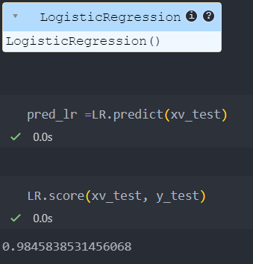

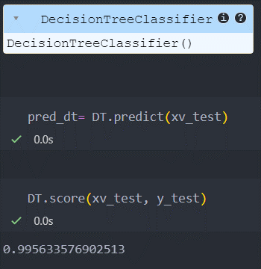Decision Tree Classification

Gradient Boosting Classifier

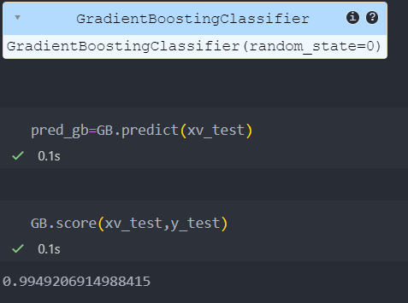

Random Forest Classification

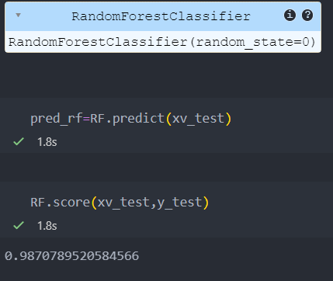

**CONCLUSION**

**Potential benefits:**

* **Empowering users:** A well-trained fake news detector can equip users with a valuable tool to assess the credibility of information they encounter online.
* **Combating misinformation:** By automatically identifying fake news articles, the detector can help reduce the spread of misleading information and promote a healthier online environment.
* **Supporting fact-checkers:** The detector can assist fact-checkers by prioritizing potentially fake news articles for further investigation.

**Limitations and challenges:**

* **Data quality:** The effectiveness of the model hinges on the quality and comprehensiveness of the training data. Datasets with a good balance of real and fake news, along with diverse writing styles and topics, are crucial for robust performance.
* **Evolving tactics:** Creators of fake news constantly adapt their techniques. The model needs to be regularly updated with new data and potentially require adjustments to stay effective against evolving tactics.
* **Bias and fairness:** Biases can creep into the training data and algorithms, leading to unfair or inaccurate detection of certain types of news. Careful selection of data sources and ongoing monitoring are essential to mitigate bias.

**Overall, building a machine learning model for fake news detection is a promising approach with the potential to empower users and combat misinformation. However, it's crucial to acknowledge the limitations and continuously work towards improving data quality, adapting to evolving techniques, and mitigating bias.**

**Additionally, consider mentioning:**

* The importance of combining automated detection with human expertise for a more comprehensive approach to identifying fake news.
* The role of media literacy in educating users on how to critically evaluate information they encounter online.

1. **REFERENCES**

For Datasets:

https://www.kaggle.com/datasets/bjoernjostein/fake-news-data-set